**Jobsheet-1: Web Server Installation and Basic HTML**

**Course: Web Design and Programming**

Erwan Majid/08/2i

**Link github:** [**https://github.com/Majid5654/Semester-3/tree/master/Week1**](https://github.com/Majid5654/Semester-3/tree/master/Week1)

* **Practical Section 1. Laragon Installation**

1. Record the results (question No. 1). Include a screenshot of the display and provide an

explanation. Please provide your answer below.

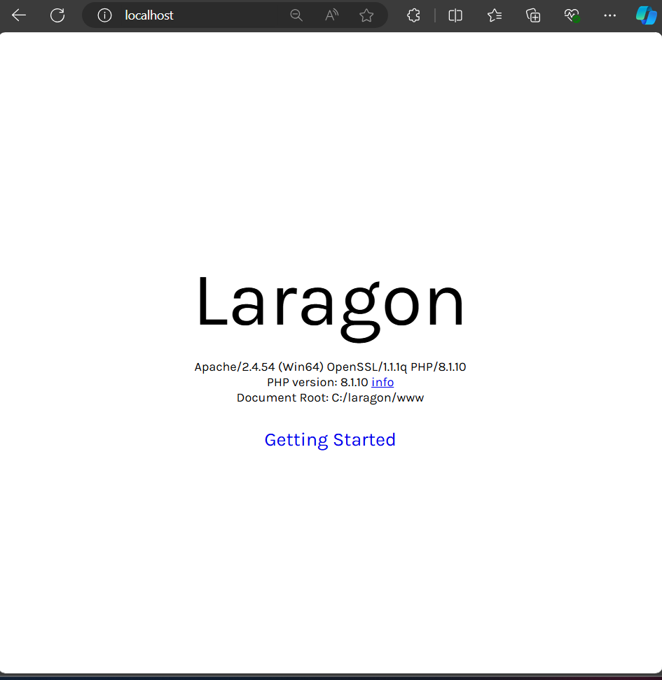

-This mean the laragaon apache is turn on and work properly

* **Practical Section 2: Starting HTML**

Observe what appears in the browser

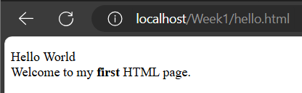

1. Record your observations (question No. 2) and write your answer below.

-<p> tags mean make paragraph

-Hello World This a text string that will be displayed as the first part of the paragraph

-<br> tag mean the text that follows will appear on a new line

- <b> first</b>.: another text string where the word "first" is wrapped in <b> tags.which mean <b> tag is bold text

1. Remove the <br> tag from the code, observe the difference, and describe below what the

function of the <br> tag is. (question No. 3) Write your answer below.

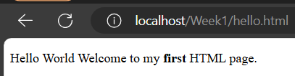

* Function <br> tag the text that follows will appear on a new line,so if we remove the tag br ,the new line doesn’t appear
* **Practical Section 3: Text Formatting**

1. Record your observations (question No. 4) and write your answer below

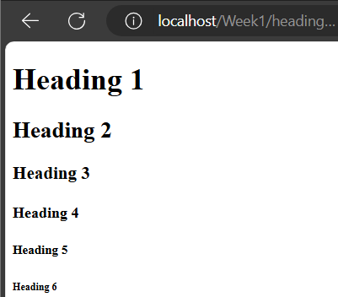

-<h1>Heading 1</h1>:

<h1> tag used to create the largest and most important heading

<h2>Heading 2</h2>:

<h2> tag creates a slightly smaller heading than <h1>.

<h3>Heading 3</h3>:

<h3> tag is used for a heading that's smaller than <h2>

<h4>Heading 4</h4>:

<h4> tag creates a smaller heading than <h3>

<h5>Heading 5</h5>:

<h5> tag creates a heading smaller than <h4>

<h6>Heading 6</h6>:

<h6> tag creates the smallest heading

1. Record your observations (question No. 5) and write your answer below.

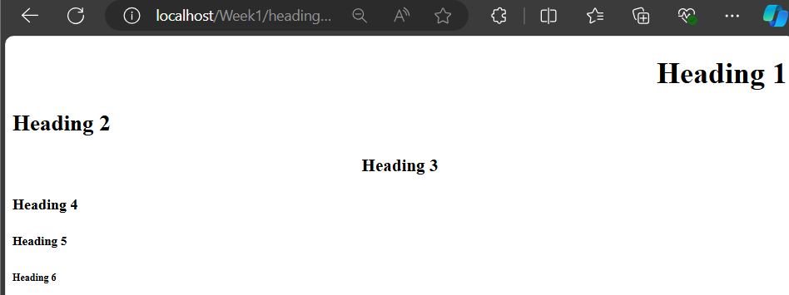

-<h1 align="right">Heading 1 </h1>:

<h1> tag creates a top-level heading

align="right" attribute is used to align the text to the right side of the page

<h2 align="left">Heading 2 </h2>:

align="left" attribute aligns the text to the left side of the page

<h3 align="center">Heading 3</h3>:

align="center" attribute centers the text on the page.

<h4> Heading 4</h4>:

This tag does not have an alignment attribute, so the text will be aligned to the left by default.and so on until h6

1. Record your observations (question No. 6) and write your answer below.

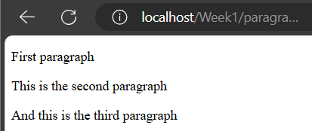

-The <p> tag is used to define a paragraph of text and </p> tags will be treated as a distinct paragraph

<p> First paragraph </p>: This creates the first paragraph with the text "First paragraph."

1. Record your observations (question No. 7) and write your answer below.

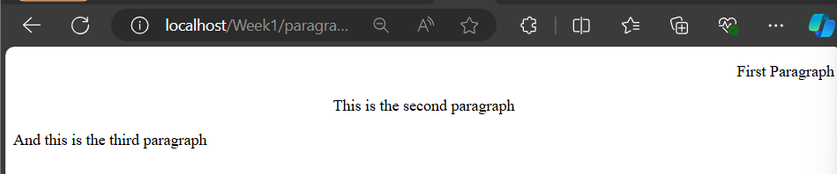

-<p align="right">First Paragraph</p>

<p> Tag: defines a paragraph.

align="right" Attribute: aligns the text within the paragraph to the right side of the container

The text "First Paragraph" is placed inside this paragraph and will appear right-aligned on the page.

And for center and left same,just change the code

* **Practical Section 4 : Font**

1. Record your observations (question No. 8) and write your answer below.

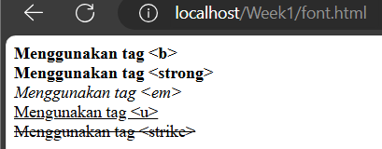

-<b>Menggunakan tag &lt;b&gt;</b>:

The <b> tag is used to make the text "Menggunakan tag <b>" bold.

The &lt; and &gt; < and > characters, respectively, to display the <b> tag as text rather than as an HTML element.

-<strong>Menggunakan tag &lt;strong&gt;</strong>:

The <strong> tag also makes the text bold

"Menggunakan tag <strong>" will be displayed in bold.

-<em>Menggunakan tag &lt;em&gt;</em>:

The <em> tag is used to emphasize the text,

The text "Menggunakan tag <em>" will be italicized.

-<u>Mengunakan tag &lt;u&gt;</u>:

The <u> tag underlines the text "Mengunakan tag <u>".

-<strike>Menggunakan tag &lt;strike&gt;</strike>:

The <strike> tag strikes through the text "Menggunakan tag <strike>," creating a line through it.

* **Practical Section 5: Special Characters**

1. Record your observations (question No. 9) and write your answer below.

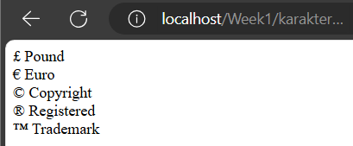

- &pound; Pound <br>,this code make symbol of pound

&euro; Euro <br>,this code make symbol of euro

&copy; Copyright <br>,this code make symbol of copright

&reg; Registered <br>,this code make symbol of registered

&trade; Trademark <br>,this code make symbol of trademark

* **Practical Section 6: Horizontal Line**

1. Record your observations (question No. 10) and write your answer below.

-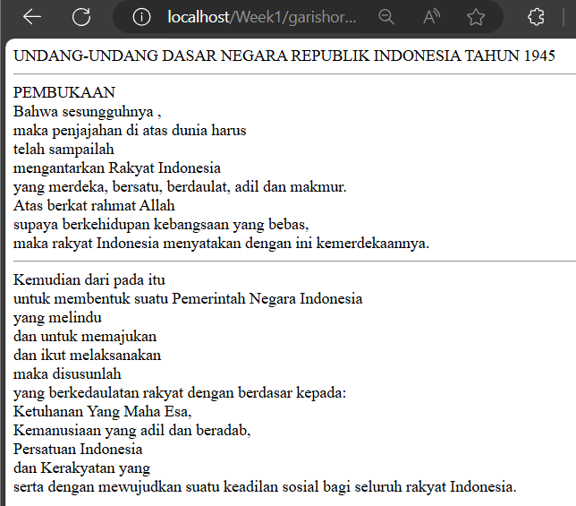

-tag <hr> to make Line horizontal

* **Practical Section 7: Using List**

1. Record your observations (question No. 11) and write your answer below.

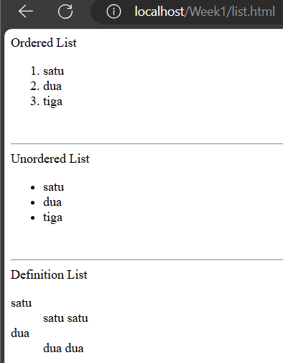

-Ordered List (<ol>): Items are numbered sequentially (1, 2, 3).

Unordered List (<ul>): Items are bulleted.

Definition List (<dl>): Items are defined with terms (<dt>) and their descriptions (<dd>).

* **Practical Section 8: Coloring**

1. Record your observations (question No. 12) and write your answer below.

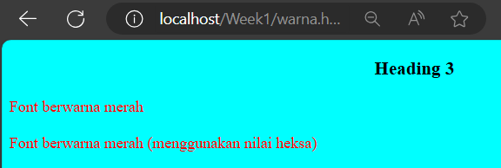

-appear font using red color,background aqua color,and the heading 3 is at the center.It because

- Background Color: The <body> has an aqua background (bgcolor="aqua").

-Heading: An <h3> heading is centered.

-Font Color: <font> tag to set text color—one with a named color ("red") and one with a hexadecimal color code (#FF0000 for red).so it appear same color

* **Practical Section 9: Working with Images**

1. Record your observations on the two methods of displaying images on the webpage (question

No. 13) and write your answer below.

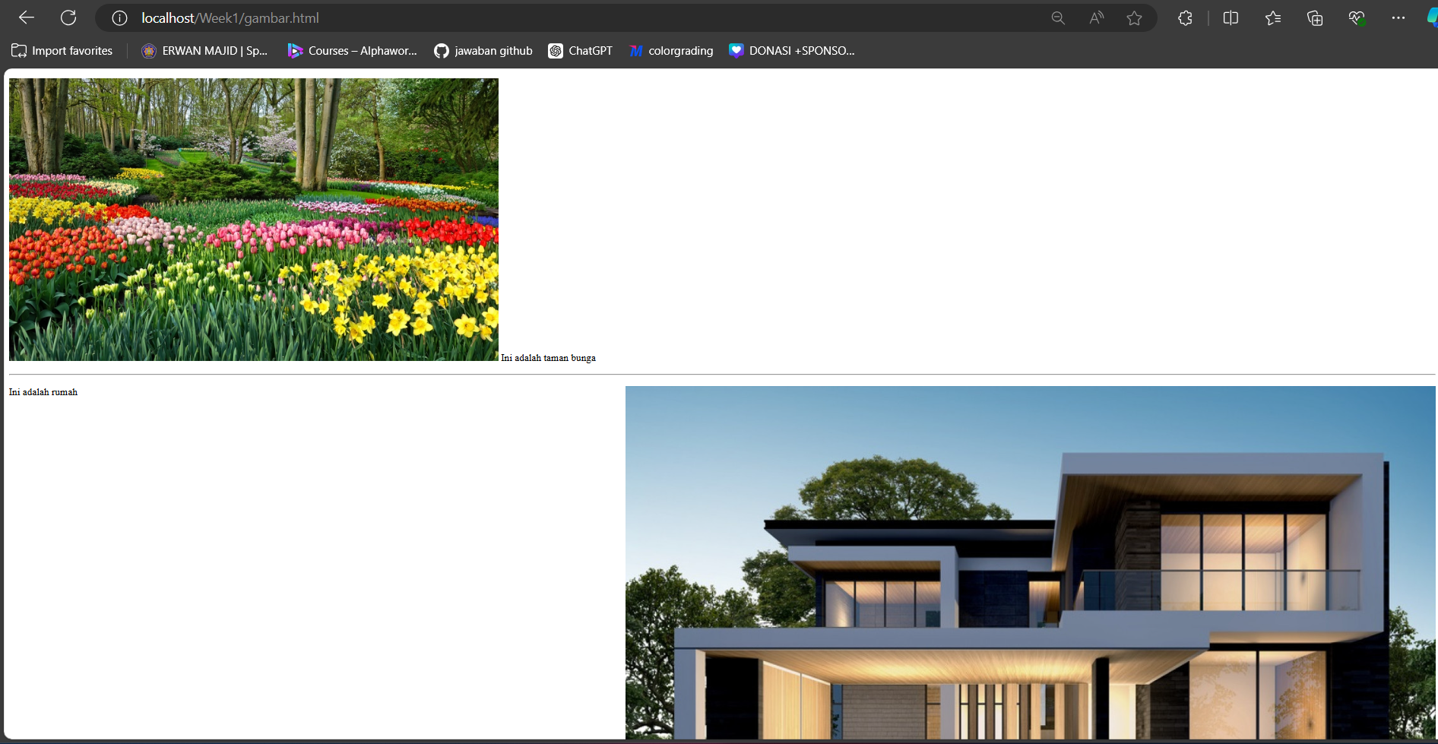

-there is 2 method to input picture ,first using <img src”name your file”> it will work if yout file is in the same directory with your html file

-and second way is using path <img src “path location”> it will work if your image location is in the sub folder of html file,which you must type img/namafile.jpg

* **Practical Section 10 : Link**

1. Record your observations (question No. 14) and write your answer below

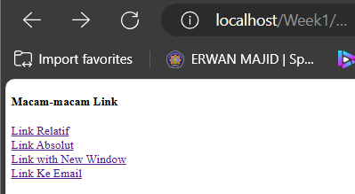

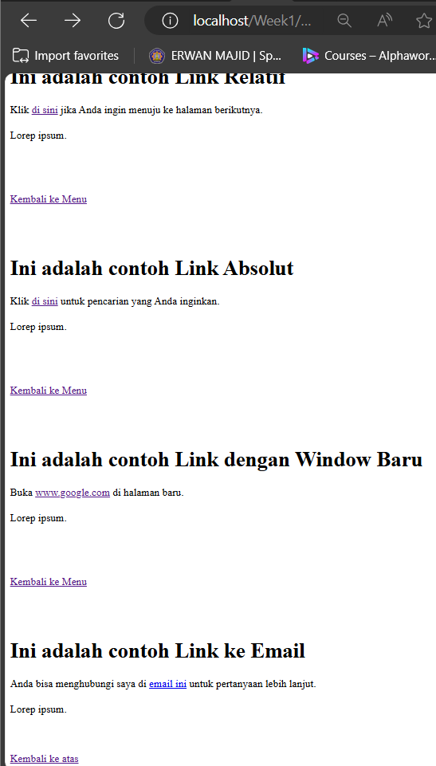

-Anchor Links: These links navigate to specific sections within the same page using href="#LinkRelatif", href="#LinkAbsolut"

-Relative Link: This link (href="gambar.html") points to another page with same directory where it save.

Absolute Link: This link (href="https://www.google.com") directs to an external website (Google).

Link Opening in a New Tab: The link (target="_blank") opens the external website in a new browser tab.

Email Link: This link (href="mailto:3rwanmajid@gmail.com") opens the user's email client to send an email.

* **Practical Task Section 10: Links**

Create a webpage and name it tugasLink.html.

Display an image that contains a link to <https://www.google.com>

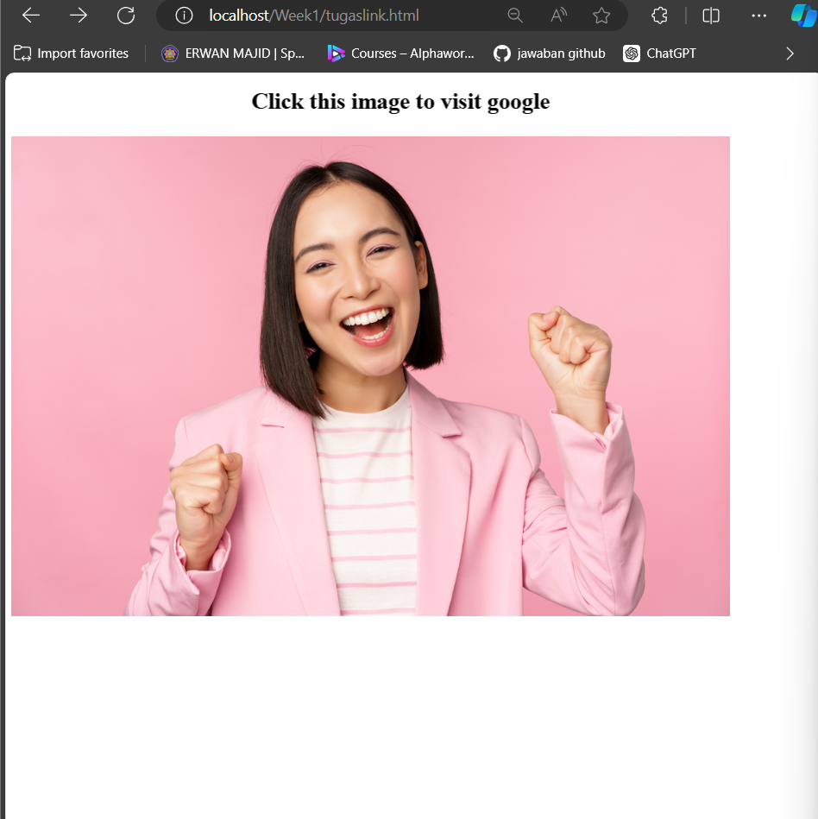

* **Practical Section 11 : Table and Table Formatting**

1. Record your observations (question No. 15) and write your answer below.

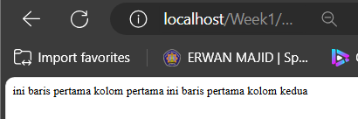

1. Record your observations (question No. 16) and write your answer below

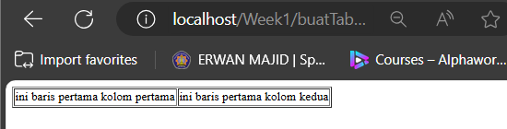

-make border each column

1. Write down the code for the modified buatTabel.html. (question No. 17) and write your

answer below

-<body>

<table border="1">

<tr>

<td>ini baris pertama kolom pertama</td>

<td>ini baris pertama kolom kedua</td>

<td>ini baris pertama kolom ketiga</td>

</tr>

<tr>

<td>ini baris kedua kolom pertama</td>

<td>ini baris kedua kolom kedua</td>

<td>ini baris kedua kolom ketiga</td>

</tr>

</table>

</body>

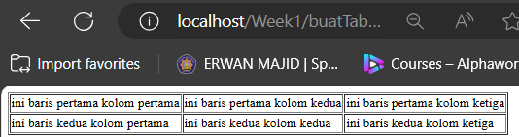

1. Note the changes here (question No. 18) and write your answer below

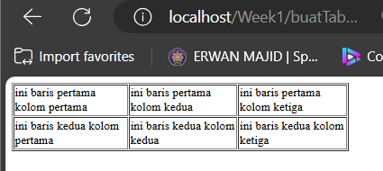

-it sets the table's height to 100% of its container and its width to 40% of its container

1. What do you understand about the difference between using and omitting % in the code? Note your understanding here (question No. 19) and write your answer below.

-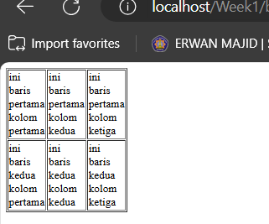

-If % symbol from the height and width attributes is gone, the values are interpreted as pixels automatically

1. Note the changes here (question No. 20) and write your answer below.

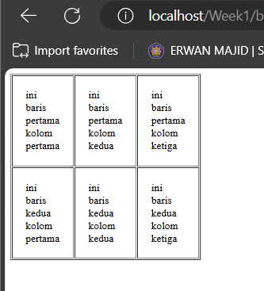

-With cellpadding="20" inside each cell has 20 pixels of space (padding) between the content and the cell border

1. Note the changes here (question No. 21) and write your answer below

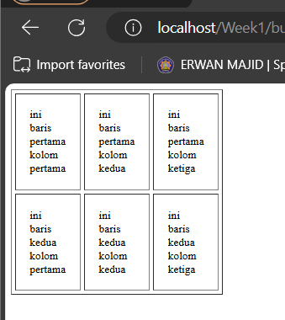

-With cellspacing="5": There is 5 pixels of space between the borders of adjacent cells

1. Note your observations here (question No. 22) and write your answer below

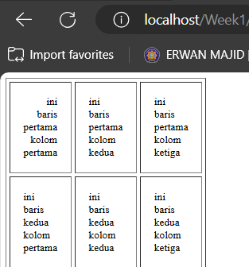

-align="right": this make first cell of the first row is aligned to the right side of the cell

1. Note your observations here (question No. 23) and write your answer below.

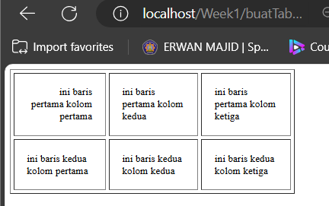

-The table's height and width scale relative to its container. height="100%" makes the table take up the full height of its container, and width="40%" makes it occupy 40% of the container's width.

-valign="bottom" attribute vertically aligns the content at the bottom of the cell. This means the text "ini baris pertama kolom pertama" will be positioned at the bottom-right corner of the cell.

1. Note your observations here (question No. 24) and write your answer below.

-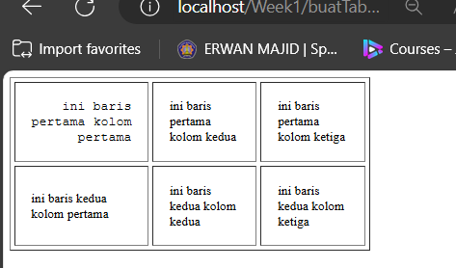

-it affect in first row first column with different style font

1. Write the modified code from step 34 in the buatTabel.html file here (question No. 25). And write your answer below

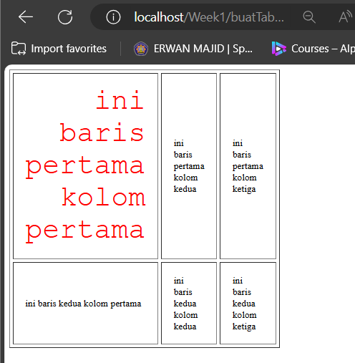

-color="red": This attribute sets the text color to red.

-size="15": This attribute sets the font size to 15

1. (question No 26) Write down your code here

-<table border="1" height="100%" width="40%" cellpadding="20" cellspacing="5" >

<tr>

<td align="right" valign="bottom">

<font face=courier color="red" size="5"> ini baris pertama kolom pertama </font></td>

<td>ini baris pertama kolom kedua</td>

<td>tambah 1 kolom</td>

</tr>

<tr>

<td colspan="2">

ini sekarang menjadi gabungan 2 kolom </td>

</tr>

</table>

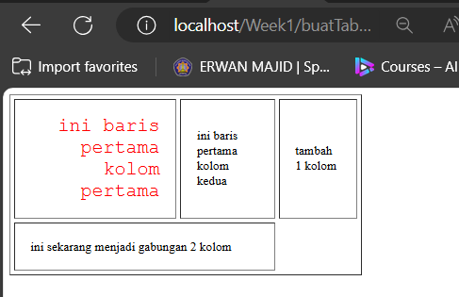

1. (question No 27) Write down your code here

-

<table border="1" height="100%" width="40%" cellpadding="50" cellspacing="5" >

<tr>

<td align="right" valign="bottom">

<font face=courier color="red" size="5"> ini baris pertama kolom pertama </font></td>

<td>ini baris pertama kolom kedua</td>

<td>tambah 1 kolom</td>

</tr>

<tr>

<td colspan="1">

ini juga tambah 1 kolom lagi </td>

<td colspan="2">ini sekarang menjadi gabungan 2 kolom</td>

</tr>

</table>

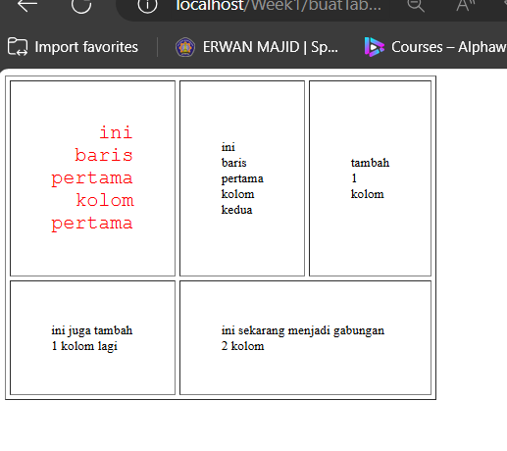

1. Note your observations here (question No. 28) and write your answer below.

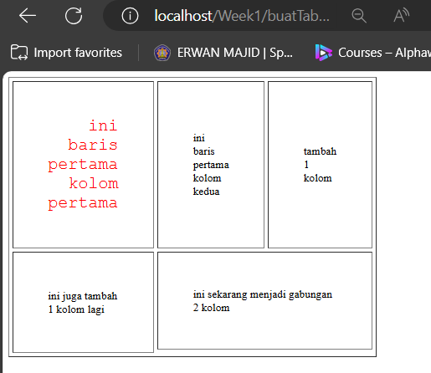

-there is a different size between “ini juga tambah 1 kolom lagi” and “ini sekarang menjadi gabungan 2 kolom”

1. Note your observations here (question No. 29) and write your answer below.

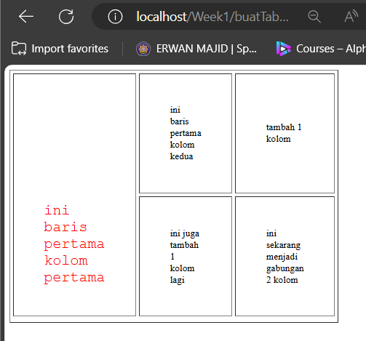

-rowspan="2": This attribute causes the cell to span across two rows.so between 2 rows

**Practical Section 12 : Working with Forms in HTML**

1. Note your observations and understanding here (question No. 30) and write your answer below.

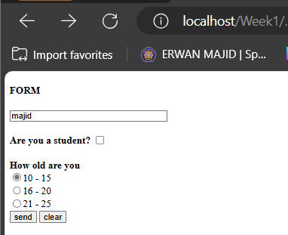

- the POST method to submit data to "gambar.html." The form includes a heading labeled "FORM," a text input field for users to enter their name with a default value of "Enter your name here," a checkbox asking if the user is a student, and three radio buttons to select their age range (10-15, 16-20, or 21-25).There are "send" and "clear" buttons for submitting and resetting the form fields, respectively.

1. Record the code you added in step 7 here (question No. 31) and write your answer below.

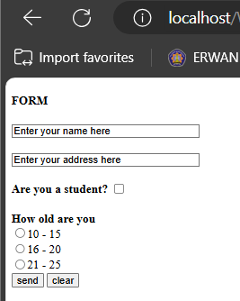

-<input type="text" name="address" size="30" value="Enter your address here"> field is to input their address in addition to their name.

1. Does the display in the browser look like the one shown below? (question No. 32).

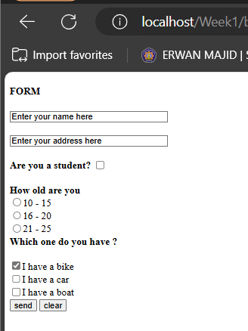

-yes ,there is a new section captures what vehicles do users own. This section comprises three check boxes that enable users to select one or more (bike, car, boat).and default is checked “I have a bike”

1. Write down here the code for the entire checkbox configuration, including the code for the

checkbox you just added. (question No. 33). Write your answer below

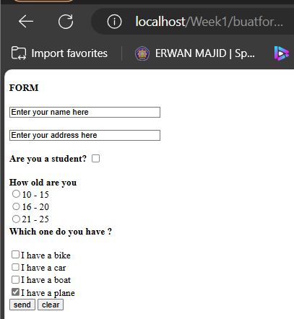

-A new checkbox input <input type="checkbox" name="vehicle4" value="Plane" checked> was added with the label "I have a plane.",and it checked on plane

1. Note here what the code snippet in step 17 means (how it works).(question No. 34) Write your answer below.

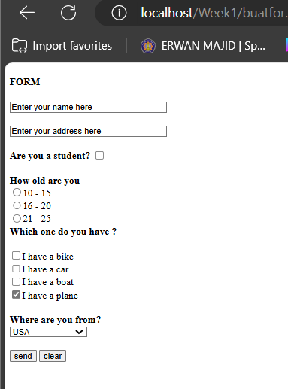

-<select>: is dropdown menu which allowing users to make a selection from predefined options than typing in free text.

1. 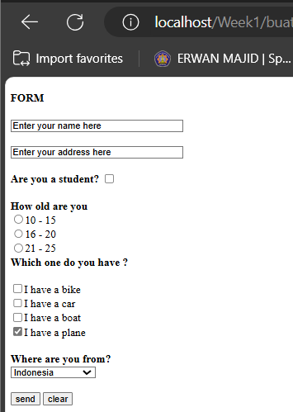Note the changes here (question No. 35) and write your answer below.

**-**The default is set to Indonesia which in code <option value="Indonesia" selected>Indonesia,so if we open the web,first appear is we choose Indonesia

1. Note the changes here (question No. 36) and write your answer below.

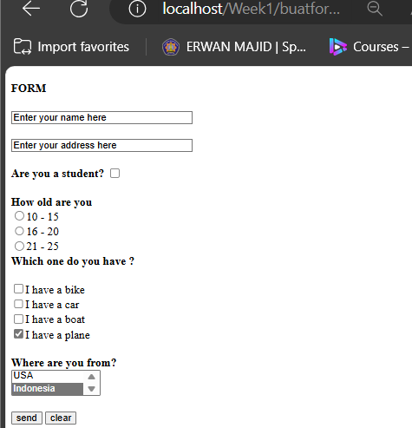

-Two options are visible at once in a list box, and users can scroll to see other options if more than two exist.

1. 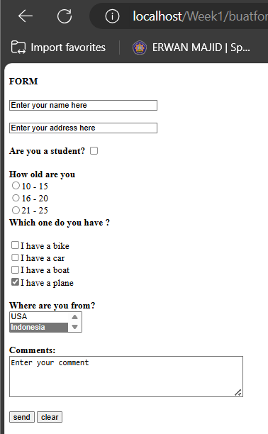Record the code you added in step 26 here. (question No. 37) and write your answer below.

- A text are to allow users to enter longer comments. This is created using the <textarea> tag.Added for user comments, providing more space for longer text input

Please record the code you added in step 29 here (question No. 37). Write your answer here-

-Same, A text are to allow users to enter longer comments. This is created using the <textarea> tag.Added for user comments, providing more space for longer text input

1. Note your observations here (question No. 38) and write your answer below

Post method:

- 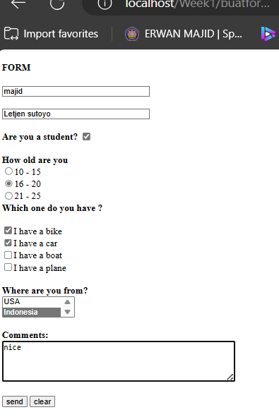

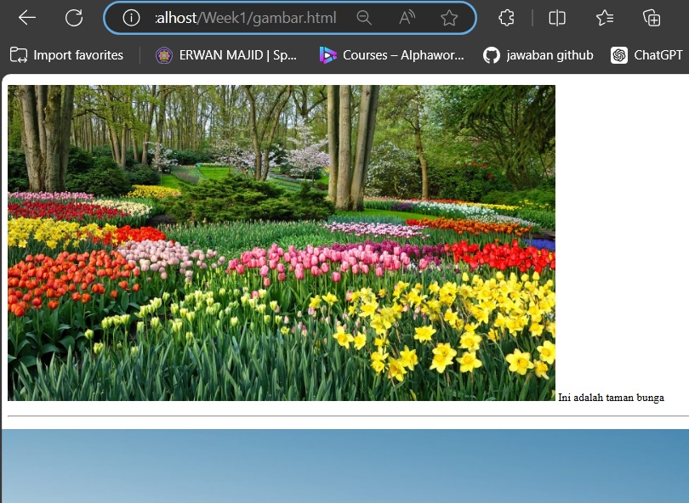-after click send button,the page directed to gambar.html and the url is week1/gambar.html

Get method:

The url addres after change post to get is:

<http://localhost/Week1/gambar.html?var1=majid&address=Letjen+sutoyo&var4=r2&vehicle2=Car&var6=Indonesia&comments=nice&var5=send>

-the differences between the GET and POST methods is ;

* method="POST", the form data is not visible in the URL after submission
* If method="GET"the form data would be appended to the URL as query parameters

LINK GITHUB:

<https://github.com/Majid5654/Semester-3/tree/master/Week1>